Software as a Service (SaaS)
# Source: Chatgpt (GPT-5-Mini) at [1/16/2026]
SaaS is a cloud computing service model in which software applications are delivered over the Internet.
Users can access applications directly via a web browser or app, without installing, managing, or maintaining the underlying infrastructure or software.

Definition
# Source: Chatgpt (GPT-5-Mini) at [1/16/2026]
SaaS:
- Provides ready-to-use software applications hosted by a cloud provider
- Users only interact with the application and data
- Provider manages infrastructure, OS, middleware, and software updates

Architecture Diagram
# Source: Chatgpt (GPT-5-Mini) at [1/16/2026]
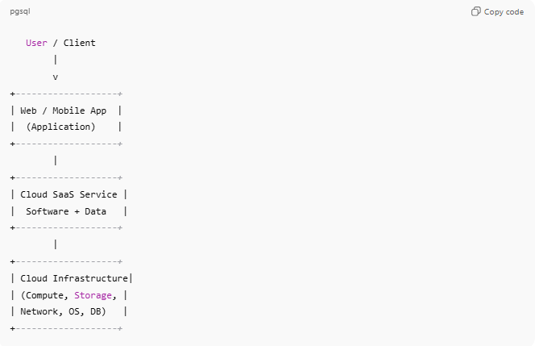
User / Client
|
v
+-------------------+
| Web / Mobile App |
| (Application) |
+-------------------+
|
+-------------------+
| Cloud SaaS Service |
| Software + Data |
+-------------------+
|
+-------------------+
| Cloud Infrastructure|
| (Compute, Storage, |
| Network, OS, DB) |
+-------------------+
- User responsibility: Only using the app and managing their data
- Provider responsibility: Everything else

Key Features
# Source: Chatgpt (GPT-5-Mini) at [1/16/2026]
- Access via web browser or app
- Automatic updates and maintenance
- Multi-tenant architecture (shared resources for many users)
- Pay-as-you-go subscription model

Examples
# Source: Chatgpt (GPT-5-Mini) at [1/16/2026]
- Gmail / Outlook 365 – Email as a service
- Google Docs / Microsoft 365 – Office applications in the cloud
- Salesforce – Customer relationship management (CRM)
- Slack / Zoom – Communication and collaboration tools

Advantages
# Source: Chatgpt (GPT-5-Mini) at [1/16/2026]
- No software installation or maintenance required
- Accessible from anywhere with an Internet connection
- Scalable and cost-effective
- Automatic updates ensure latest features and security

Disadvantages
# Source: Chatgpt (GPT-5-Mini) at [1/16/2026]
- Requires Internet connectivity
- Limited customization compared to self-hosted software
- Potential privacy or security concerns
- Possible vendor lock-in

Simple Analogy
# Source: Chatgpt (GPT-5-Mini) at [1/16/2026]
- SaaS: Using a hotel room
  - You just use the room (application)
  - Hotel handles cleaning, maintenance, and utilities (infrastructure, software updates, servers)

IaaS vs PaaS vs SaaS (Quick Comparison)
# Source: Chatgpt (GPT-5-Mini) at [1/16/2026]
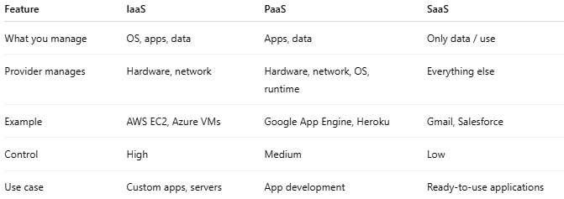
Feature | IaaS | PaaS | SaaS
What you manage | OS, apps, data | Apps, data | Only data / use
Provider manages | Hardware, network | Hardware, network, OS, runtime | Everything else
Example | AWS EC2, Azure VMs | Google App Engine, Heroku | Gmail, Salesforce
Control | High | Medium | Low
Use case | Custom apps, servers | App development | Ready-to-use applications

